

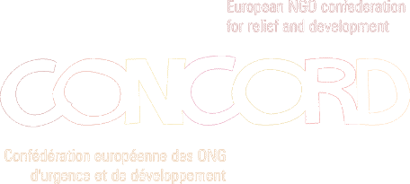


European Food Security Group (EFSG)

Input on the EC Communication Advancing African Agriculture

Executive Summary

Gerhard Schmalbruch
Secretary General of Euronaid

In February 2007 the EFSG made a submission to the European Commission (EC) on its discussion paper Advancing African Agriculture (AAA). This submission offered constructive comments to the EC on a number of issues. Whilst recognising many of the strengths of the paper - the overall level of analysis of the problems affecting African agriculture; recognition of the role of agriculture in poverty eradication; reference to the Comprehensive African Agricultural Development Programme (CAADP); and recognition of differences between African countries – the group raised concerns on a number of points.
In the meantime, the EC has presented a formal Communication on Advancing African Agriculture to the Council and the European Parliament. Although Civil Society Organisations recognise that a number of important adjustments have been introduced into the Communication, there remain substantial areas of contention, as analyses by various CSO stakeholders show.

Main points of contention

Lack of emphasis on small-scale subsistence farming: the key role of family farming needs to be much more emphasized and supported. Local and regional efforts to support agriculture in Africa should target family farmers, smallholder farmers, and local farming organisations.

Building and strengthening local and regional markets: priority should be given to building and protecting local, national and regional agricultural markets and to ensuring the facilitated access of small producers to these markets on fair and equal terms.

Inclusion of Rural Stakeholders: AAA needs to support efforts at national and regional level to involve rural stakeholders and their representative organisations in the consultation processes on policy issues that affect them. Capacity building and people-centred advocacy for rural populations is essential to this process.

Promotion of regional agricultural policies: together with the inclusion of rural stakeholders, this needs to be given more importance.

Role of Women: the importance of women in African agriculture cannot be overstated. AAA measures need to be targeted more explicitly at developing dedicated programmes to support the role of women in African agriculture.

The Disease Burden: health and agriculture are inextricably linked - good health affects agriculture by boosting people’s capacity for work and thus increasing how much they can produce. If agricultural policies and programs fail to take account of health realities (e.g. HIV Aids, Malaria), they are unlikely to meet their objectives and can actually worsen the spread of diseases.

Consultation Process: the consultation process is, in itself, integral to the quality and acceptance of policies and strategies by all relevant stakeholders. Therefore in 2002, the Commission adopted minimum standards for the consultation process. Whilst we recognise the numerous attempts made by the Commission to consult various civil society organisations at different stages of the drafting process for AAA, the consultation does not meet the Commissions’ own standards.
Without sufficient time and systematic consultation, civil society encounters extreme difficulties in positioning itself in an inclusive and participatory manner, particularly with regard to the systematic inclusion of our Southern partner organisations in self-conducted and comprehensive processes.

